**AI ASSITED CODING LAB 2.1**

**Hall no:2403A51323**

**Name: Yarlagadda Mohith Sai Shankar**

**Batch:24BTCAICSB13**

Assignment1

**Task 1:**

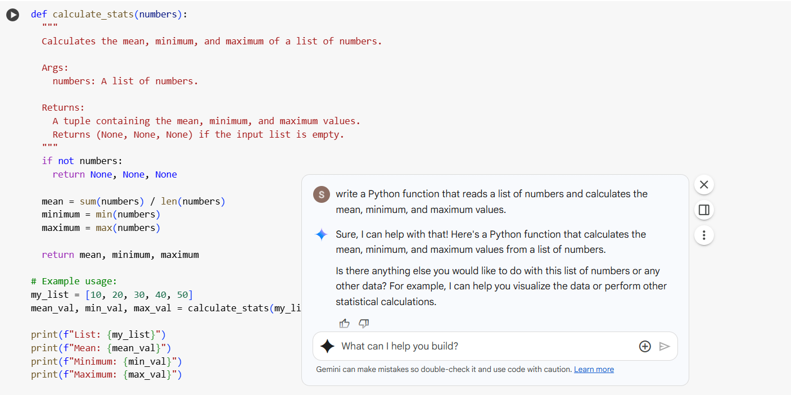

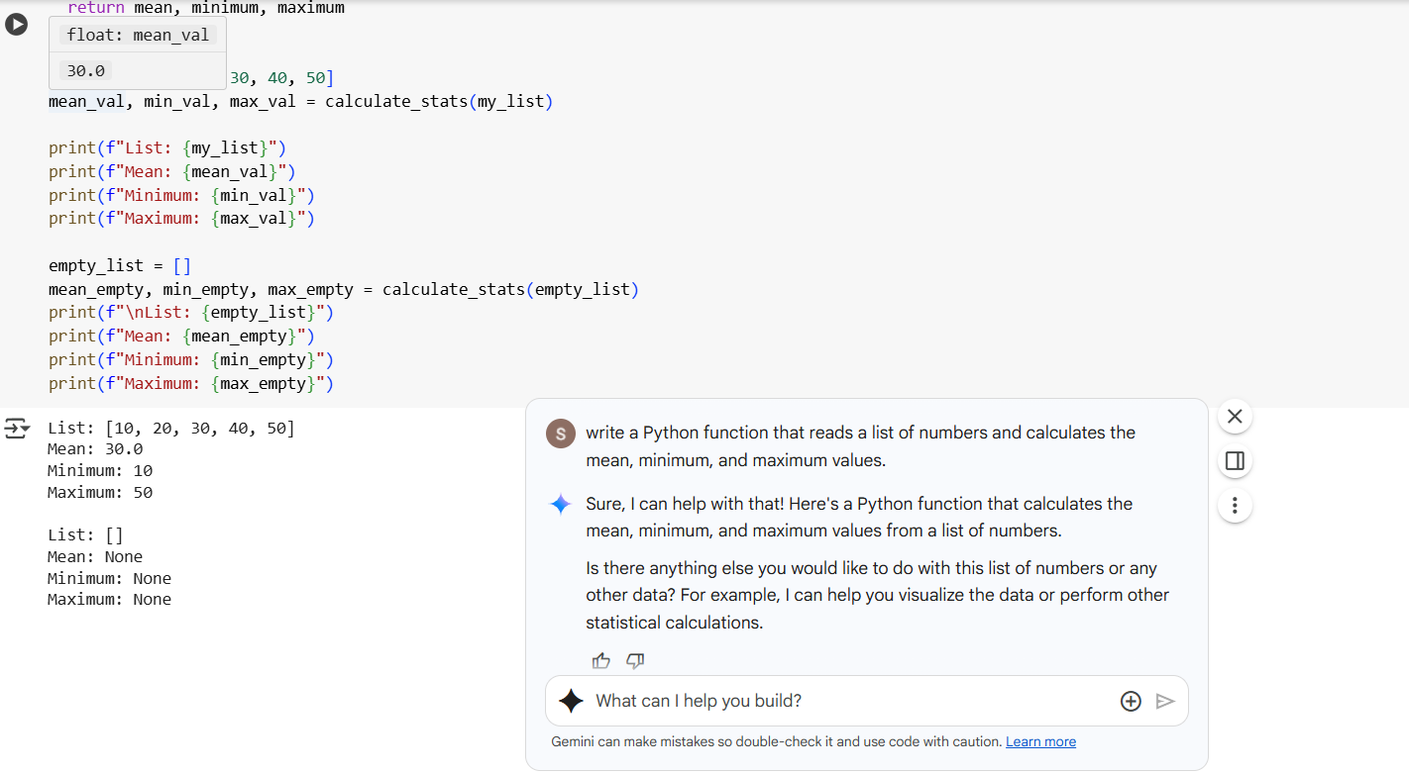

**Task2:**

**Gemini**

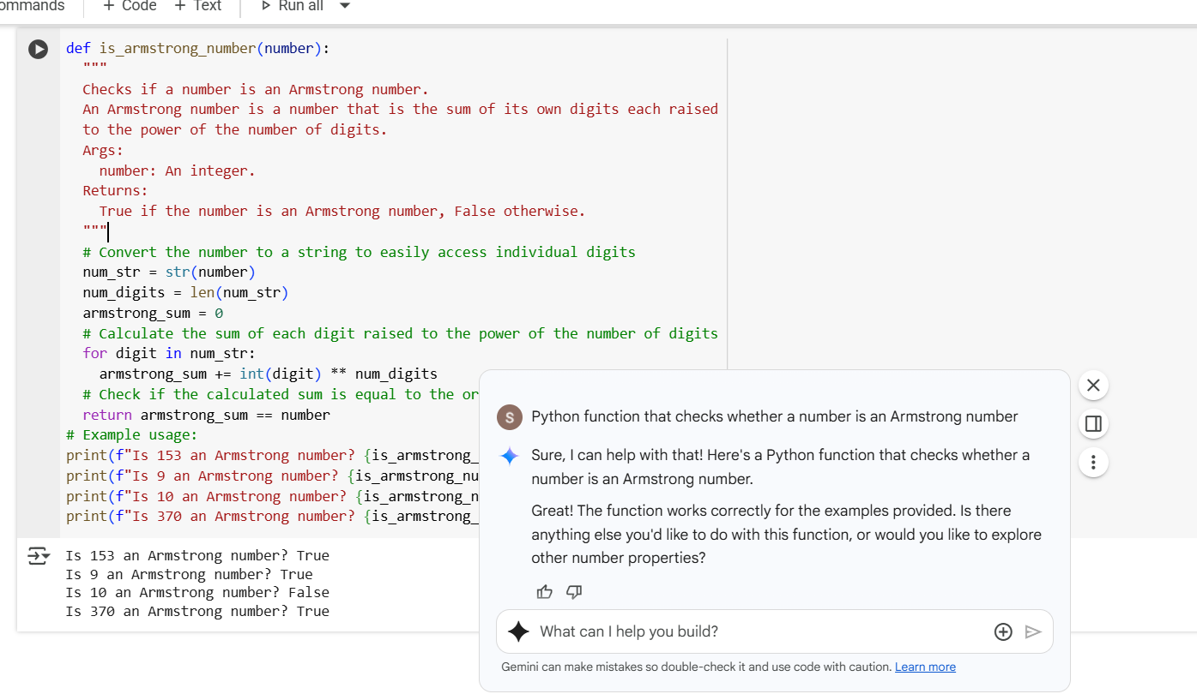

**Copilot:**

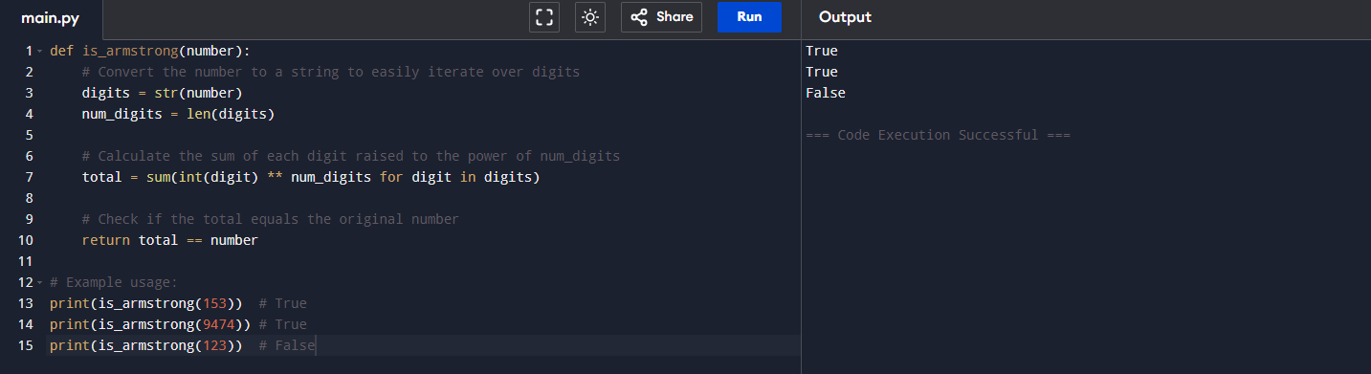

**Observations of Task 2:**

|  |  |
| --- | --- |
| Gemini | Copilot |
| Given code is very small | Given code is somewhat big |
| it taken runtime of 2s | It taken runtime of 3s |
| the respond is very fast | The respond is slow |
| Output matches expected results | Output matches expected results |
| Gives minimal explanations | Minimal explanations |

**Task 3:**

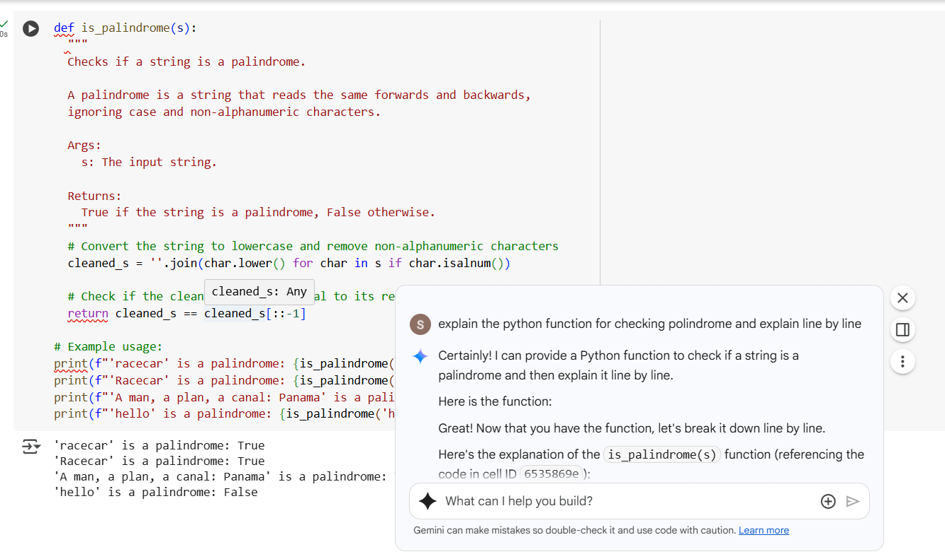

Explanation:

The palindrome function takes a string and checks whether it reads the same forward and backward, ignoring case and non-alphanumeric characters. First, it processes the input by converting all characters to lowercase and removing anything that's not a letter or number—this ensures that spaces, punctuation, and capitalization don’t affect the result. Then, it compares this cleaned version of the string to its reverse. If both are identical, the function returns true, indicating the string is a palindrome; otherwise, it returns false

**TASK 4:**

**Cursor ai:**

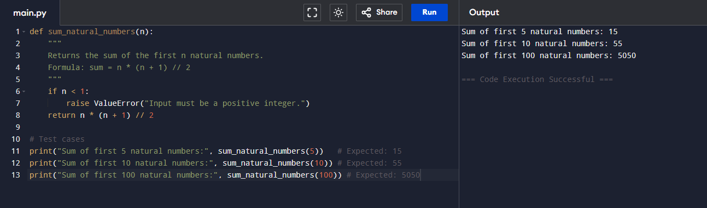

**Gemini:**

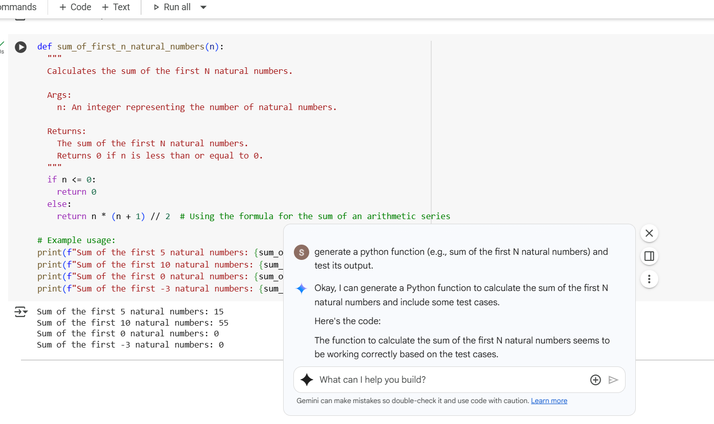

**Task 5:**

**Student Code:**

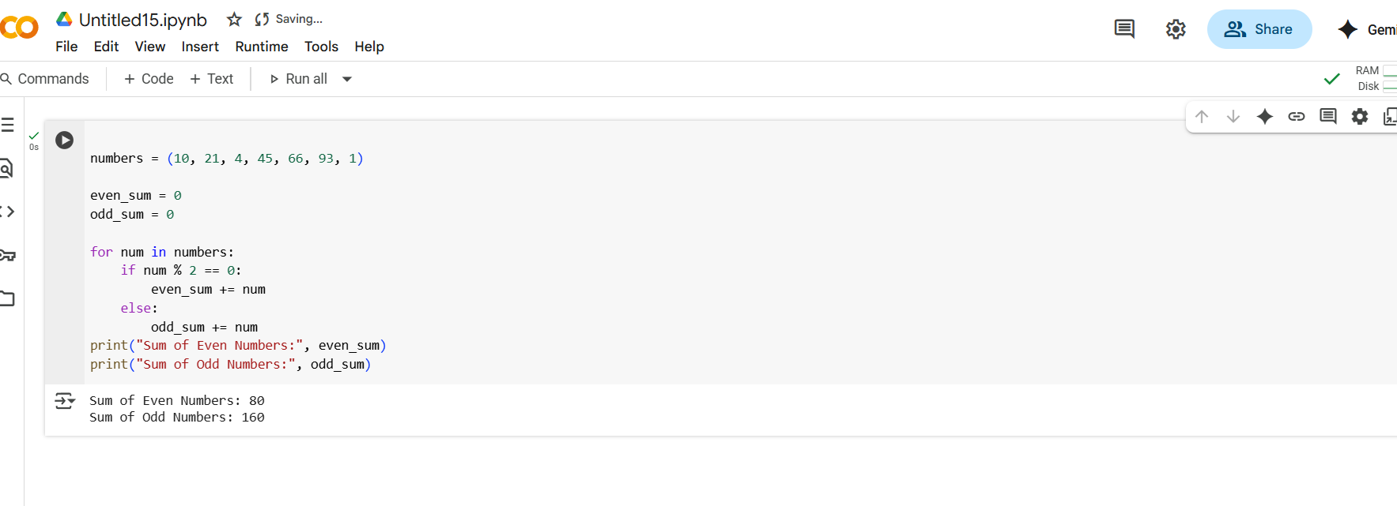

**Refactored Code:**

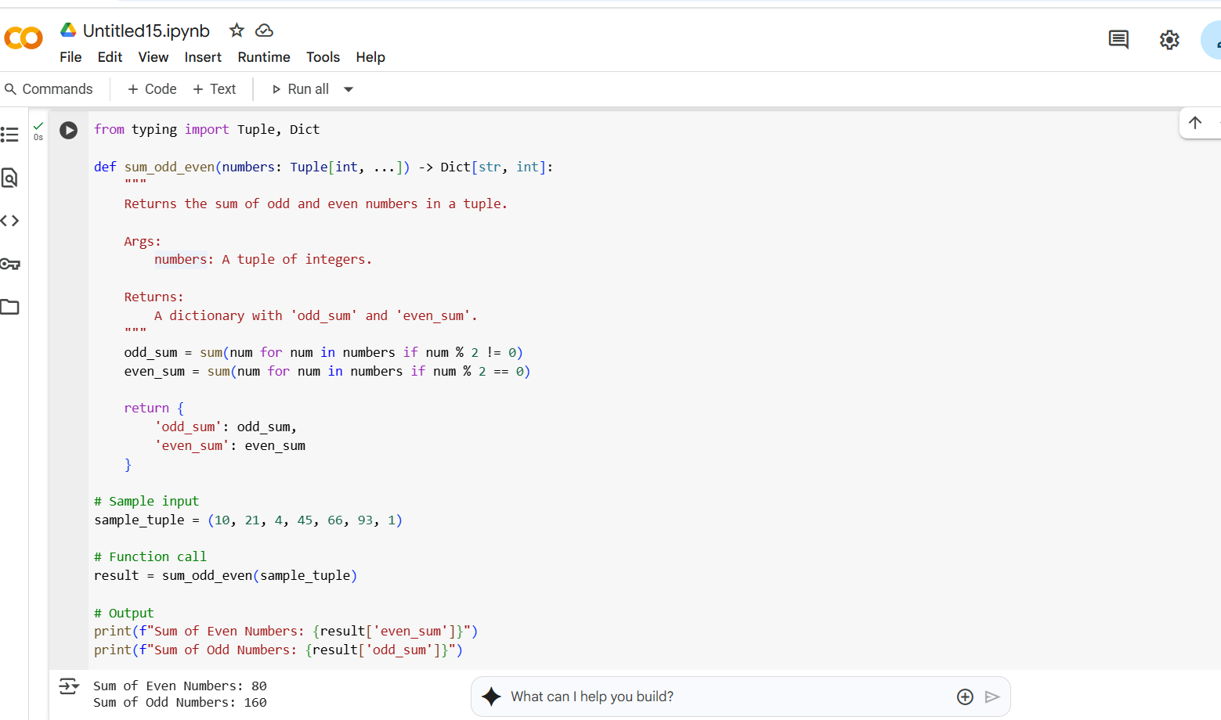

**Explanation:**

improvements Made

* **List Comprehensions**: Replaced manual loops with concise sum() and generator expressions.
* **Type Hints**: Added Tuple[int, ...] and Dict[str, int] for clarity and IDE support.
* **Docstring**: Clear explanation of function purpose, arguments, and return values.
* **Formatted Output**: Used f-strings for cleaner printing.